Section A
Particulars of Log Book Scheme
Particulars of Graduate Engineer under training
Name of Candidate:
Identity Card Number:
Date of Birth: Nationality:
BEM Graduate Registration No: Date:
IEM Membership No: Date:
Discipline of Engineering:
Address:
Telephone No. (Off) (Hse/HP) Fax:
E-mail:
Degree Awarded: Year of Graduation:
Colleges / Universities attended (with dates) after SPM / STPM
1.
2.
3.
4.
Industrial training / experiences during undergraduate course
Employment |  | Employer | Designation | Key Role and Responsibilities
From | To | Employer | Designation | Key Role and Responsibilities
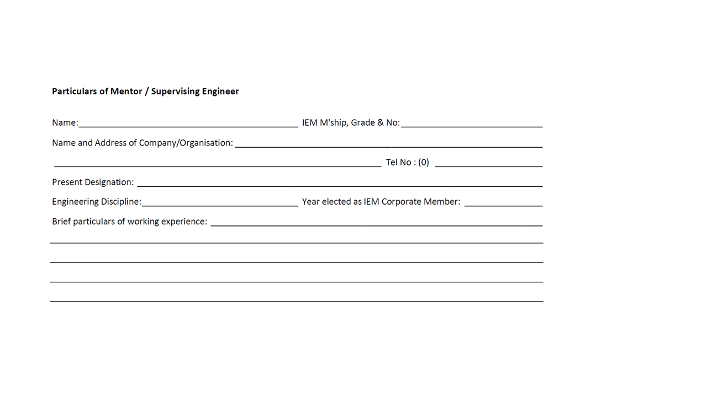
Particulars of Mentor / Supervising Engineer
Name: IEM M'ship, Grade & No:
Name and Address of Company/Organisation:
Tel No: (0)
Present Designation:

Engineering Discipline: __________________________Year elected as IEM Corporate Member: _______________

Brief particulars of working experience:

_____________________________________________________________________________________________

_____________________________________________________________________________________________

_____________________________________________________________________________________________

_____________________________________________________________________________________________

_____________________________________________________________________________________________

Particulars of Mentor / Supervising Engineer (if there is a change)
Name: IEM M'ship, Grade & No:
Name and Address of Company/Organisation:
Tel No: (0)
Present Designation:

Engineering Discipline: __________________________Year elected as IEM Corporate Member: _______________

Brief particulars of working experience:

_____________________________________________________________________________________________

_____________________________________________________________________________________________

_____________________________________________________________________________________________

_____________________________________________________________________________________________

_____________________________________________________________________________________________

Section B
Summary of Practical
Training & Experience

PRACTICAL TRAINING & EXPERIENCE RECORDS SUMMARY

Annual Summary of Competencies Obtained
Category | Element | Brief Evidences | Mentor's Comments | Date
A Engineering Knowledge Application | A1
A Engineering Knowledge Application | A2
A Engineering Knowledge Application | A3
B Problem Solving | B1
B Problem Solving | B2
B Problem Solving | B3
C Management | C1
C Management | C2
C Management | C3
C Management | C4
D Interpersonal Skill | D1
D Interpersonal Skill | D2
D Interpersonal Skill | D3
E Professional Ethics | E1
E Professional Ethics | E2
E Professional Ethics | E3
E Professional Ethics | E4
E Professional Ethics | E5
Mentor recommendations
Year 1/2/3 Recommendation
Support for PI
Require more exposure
Date

Quarterly Summary of Competencies Obtained

From - To  (Month & Year) | Position Held / Name of Employer | Brief description of Duties  (Full details to be documented  in Section C) | Area of Experience (Design, Site, Management Teaching, Research) | Competency Elements Gained

COMMENTS OF SUPERVISOR/MENTOR

COMPETENCY CATEGORY A (Detailed)

A | Use a combination of general and specialist engineering knowledge and understanding to optimise the application of existing and emerging technology.
A1 | Maintain and extend a sound theoretical approach in enabling the introduction and exploitation of new and advancing technology and other relevant developments.
A2 | Engage in the creative and innovative development of engineering technology and continuous improvement systems.
A3 | Apply engineering knowledge related to local practices, codes, standards, specifications, materials, products, environmental plans and other requirements; and where appropriate, apply engineering knowledge contributed by others including suppliers, consultants, contractors, manufacturers, technologists, researchers and independent experts.

Evidence of your competence in Category A | Element | Date Obtained

COMPETENCY CATEGORY B (Detailed)

B | Apply appropriate theoretical and practical methods to the analysis and solution of engineering problems
B1 | Identify potential projects and opportunities
B2 | Conduct appropriate research and undertake design and development of engineering solutions.
B3 | Implement design solutions, and evaluate their effectiveness.

Evidence of your competence in Category B | Element | Date Obtained

COMPETENCY CATEGORY C (Detailed)

C | Provide technical and commercial management.
C1 | Plan for effective project implementation.
C2 | Plan, budget, organise, direct and control tasks, people and resources.
C3 | Lead teams and develop staff to meet changing technical and managerial needs.
C4 | Bring about continuous improvement through quality management.

Evidence of your competence in Category C | Element | Date Obtained

COMPETENCY CATEGORY D (Detailed)

D | Demonstrate effective interpersonal skills
D1 | Communicate in English or Malay Language with other at all levels.
D2 | Present and discuss proposals.
D3 | Demonstrate personal and social skills

Evidence of your competence in Category D | Element | Date Obtained

COMPETENCY CATEGORY E (Detailed)

E | Demonstrate a personal commitment to professional standards, recognizing obligations to society, the profession and the environment
E1 | Comply with relevant codes of conduct.
E2 | Manage and apply safe systems of work.
E3 | Undertake engineering activities in a way that contributes to sustainable development.
E4 | Carry out continuing professional development necessary to maintain and enhance competence in own area of practice.
E5 | Understand the legal matters pertaining to engineering profession and be able to communicate with legal personnel on these issues.

Evidence of your competence in Category E | Element | Date Obtained

Section C
Practical Training Records -
3-Month Period
PRACTICAL TRAINING RECORD – 3-MONTH PERIOD
Name of Candidate:

Effective from: To:

Brief description of practical training experience

Details of project(s) participated

Types of skills/competencies obtained:

Name of Mentor / Supervising Engineer: Discipline:_______
IEM Membership No.: P Eng. No:_______

Signature of Mentor/Supervising Engineer: __________________________________

Section D
Courses Attended
(Advisable)
COURSES ATTENDED (ADVISABLE)
Name of Candidate:

 | DESCRIPTION | DATE ATTENDED | CONDUCTED BY | CERTIFICATION
1 | Code of Ethics / Regulations
2 | Engineering Management
3 | Health and Safety
4
5
6
7
8
9
10
11
12
13
14
15
16
17
18
19
20
21
22
23
24
25

Section E
Professional Career
Development Activities
PROFESSIONAL CAREER DEVELOPMENT ACTIVITIES
Name of Candidate:
ACTIVITY | DATE | NO. OF HOURS | CERTIFICATION

